

**Engineering Technical Communications**

**GENG8000 – Section 35**

**Final Proposal**

**Generating Energy from Carbon emitted by power plants by Carbon Capture method**

**Group #8**

Milan Patel (#105173681)

Rushil Limbachiya (#110005478)

Dino Johnson (#105196057)

Jugal Surti (#105171667)

Prabish Bishungkhe (#105188597)

**Submitted to:**

Professor Jesse Ziter

Date: 11th November 2019

**Executive Summary**

According to a recent study conducted by Environment and climate change of Canada, carbon dioxide is the major greenhouse gas emitted into the atmosphere in North America. The level of CO2  is tremendously increasing day by day due to harmful human activities such as automotive and industrial emissions. Another main reason for the excessive amount of CO2 emission is the demand for electrical energy for the industries which is produced by burning fossil fuels in the power plant. This drastic increase in the levels of CO2 results in various health issues and also contributes a major factor to climate change in the city of Windsor.

The following report proposes a method to build a combined cycle power plant which traps the emitted carbon dioxide from the exhaust of the power plant and converts them back into useful byproducts. This is done by installing carbon nanotubes in the exhaust of the plant with addition to molten carbonate as an electrolyte which dissolves the CO2 emitted from burning fossil fuels. The byproducts obtained are carbon nanotube fibers and pure oxygen which is extracted from the dissolved CO2 in the electrolyte at the Cathode and Anode respectively. There are two different processes for CO2 sequestration which are pre-combustion and post-combustion.

The total estimation of this project is roughly around 1,36,100 CAD. The operational cost of this setup is around 862 CAD per ton of carbon nanotube and the initial trial time is about 300 days to analyze the efficiency and make changes to the system if needed. The government should take initiative steps to maintain the working condition of this setup at regular intervals.

If the setup at the exhaust is not properly maintained without regular inspections there is a possible chance of CO2 escaping from the exhaust which in turn has no use of setting up the process. With more time and research the efficiency of this project could be increased with fewer investments to achieve the desired output. This method is one of the best solutions to capture CO2 from power plants since the process is very simple and can be easily installed to the plant. Along with that, the carbon nanotube byproduct formed in the process can be novel revenue to the government in addition to the filtration process of CO2.

**Acronyms**

CNTs - Carbon Nanotubes

CFC- Chlorofluorocarbon

HCFC- Hydrochlorofluorocarbon

C2H2 - Acetylene

EDA - Ethylenediamine

PEI - Polyethyleneimine

MWNT- Multi-walled carbon nanotubes

FEG - Field Emission Gun

TEM - Transmission Electron Microscopy

SEM - Scanning Electron Microscope

APTS - 3-aminopropyl-triethoxysilane

CAD- Canadian Dollars

Table of Contents

**1.** **Introduction** 6

**2.** **Background and literature review** 9

**2.1.** **Effects of Carbon and its Compounds on Climate:** 9

**2.2.** **Misbalancing in the Ecosystems:** 9

**2.3.** **Co-Relation Between Fossil Fuels and Human Species:** 9

**2.4.** **Why do we need to react now?** 10

**2.4.1.** **The History behind Carbon Capture and Sequestration Technology** 11

**2.5.** **Alternate Carbon Capturing Technologies:** 11

**2.5.1.** **Pre-Combustion:** 11

**2.5.2.** **Post Combustion:** 11

**3.** **Requirements and Criteria** 12

**3.1.** **Requirements** 12

**3.2.** **Criteria** 12

**4.** **Solution Proposed** 13

**4.1.** **Capturing of carbon by Electrolyzer in power plant.** 13

**4.2.** **Process for Nanotube conversion:** 14

**4.3.** **Layout of the Plant:** 14

**4.4.** **Comparison:** 15

**4.5.** **Advantages:** 15

**4.6.** **Disadvantages:** 16

**5.** **Cost Analysis** 17

**5.1.** **Initial cost of the project** 17

**5.2.** **Operating cost of the project** 17

**6.** **Proposed Timeline** 18

**7.** **Final Recommendations and Conclusion for Project** 19

**7.1.** **Required finance for Overall Project development.** 19

**References** 20

**List of Figures**

**Figure 1:Greenhouse gas emission by different sectors in Windsor city** 6

**Figure 2: Electricity generation power plant** [1] 7

**Figure 3: Atmospheric CO2 at Mauna Loa Observatory** [4] 10

**Figure 4 Carbon Emission from Fossil Fuels** [4] 10

**Figure 5:Conventional combined cycle power plant and CC Carbon nanotube power plant with electrolyzer** [8] 13

**Figure 6: Layout of Power plant equipped with carbon capture facility** [8] 15

**List of Tables**

**Table 1: Comparison between two types of power plants** [8] 15

**Table 2:Comparision of the per ton production of CNT and aluminum** [8] 17

# **Introduction**

There are various reasons for the emission of greenhouse gases into the atmosphere due to harmful human activities. Among them, CO2 contributes to the major factor in polluting the environment in the city of Windsor. CO2 is responsible for absorbing the radiant energy released from the sun and it traps the heat inside the atmosphere causing climate changes.

The reason for major greenhouse gases emission in Windsor city are the residential, commercial and institutional, transportation and solid waste sectors and industrial; out of which transportation accounts for 36% and industrial account for 20% of the total emission, which are major contributing factor.

**Figure 1:Greenhouse gas emission by different sectors in Windsor city**

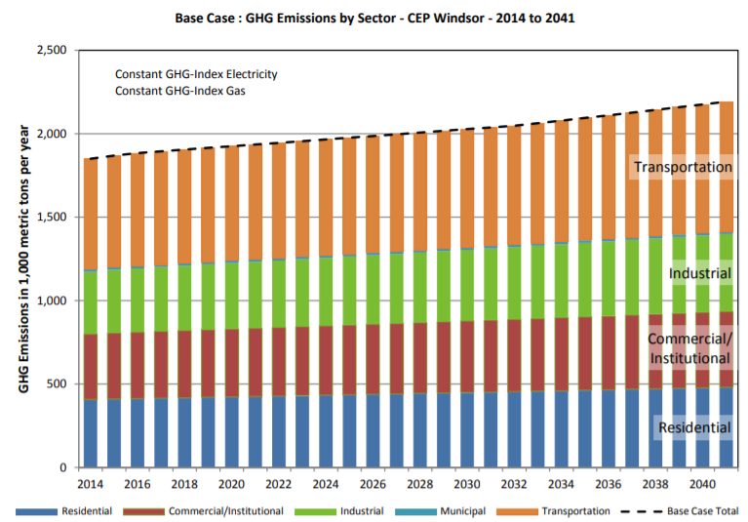

The reason behind this problem is, majority of the cargo trucks are being transported through Windsor to USA. On an average of around 2,546,977 and 34,377 trucks pass through Ambassador Bridge and Detroit Windsor tunnel respectively Windsor city every year. Along with this, industrial activities too are one of the major contributors to the increase in greenhouse gas emission, since a significant amount of natural gas is being used by the various automotive industries like Chrysler and Ford. Combustion of this natural gas produces carbon dioxide which is being released into the atmosphere.

There were different solutions provided by the team such as developing solar farms over the water surface that could extract CO2 from the water to produce renewable energy. Such method of water capture reduces the concentration of CO2 from the water, which would further help to capture more of the CO2 from the air. Giant solar floating islands would covert carbon dioxide to methanol fuel which would help reduce greenhouse gases from the atmosphere and this fuel can be used as energy, but after doing SWOT analysis of those various options and their possibilities team members reach to the solution of carbon sequestration for the gas based plants in industries which generates major of the greenhouse gases is effective and economical for the initial start.

Due to the industrial revolution in recent decades, there is a huge demand for electrical energy to operate these industries. This, in turn, causes in the increased combustion of fossil fuels to generate the required amount of electricity to meet the industrial demands. Thermal power plants are a major cause of the increased levels of greenhouse gas emissions in the atmosphere. Among which CO2 is the main cause of climate change because it traps the heat into the atmosphere thereby increasing the temperature in the environment.

Figure 1 shows us the major blocks of components used in a thermal power plant to generate electricity by burning fossil fuels. The fossils fuels are burnt inside the combustion chamber to produce the thrust required to operate the steam turbine which is coupled to the synchronous generator which in turn produces the electricity. The exhaust gases are let out into the atmosphere without proper filtration which causes climate changes.

**Figure 2: Electricity generation power plant** [1]

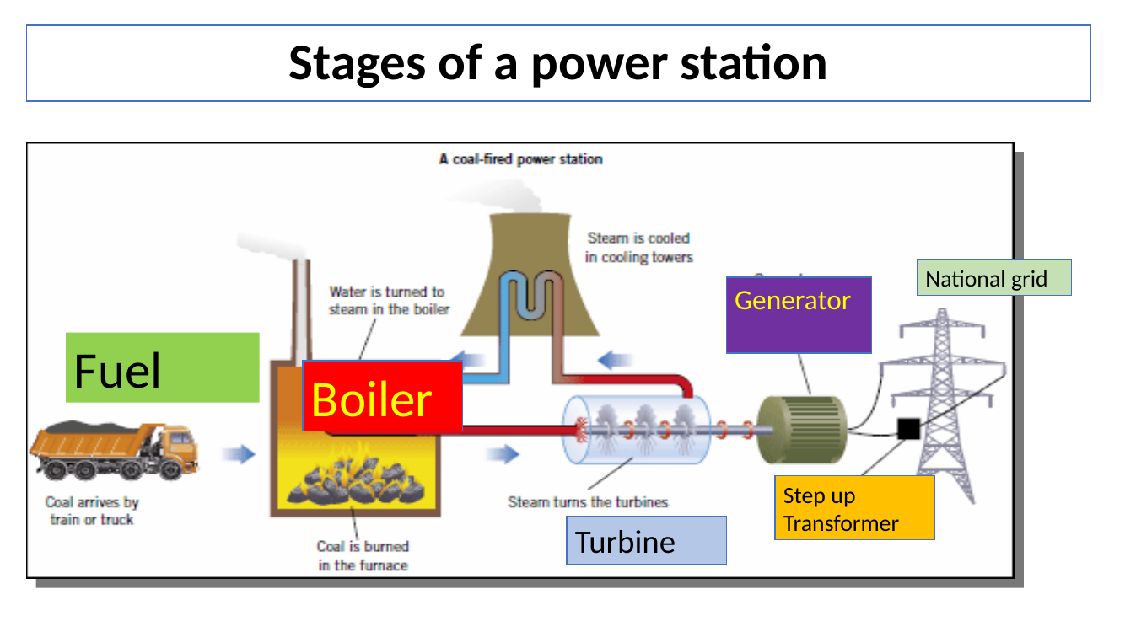

These are the different effects of increased CO2 emissions in the atmosphere:

1. Increase in global temperature.
2. Due to the increase in temperature, the ocean levels rise because of the melting ice in the Polar Regions.
3. Due to the increased temperature summers are warmer than usual which makes the place inhabitable.
4. This increased level of carbon gives rise to various health issues among all living creatures.
5. CO2 emitted from the industries mix with moisture in the air and forms clouds with high acid content. Acid rain pollutes water and soil making further impacts on our environment.

The domestic electrical energy consumed by the city of Windsor is about 35% more compared to the other cities in Ontario [2]. From the data given by reducing and monitor the community of greenhouse gas emissions, it is seen that there is a 40% rise in levels of CO2 from the industries [3]. Along with CO2, there are other gases that are released from the burning fossil fuels which cause adverse effects on our climate; gases such as CFC(Chlorofluorocarbon), HCFC(Hydrochlorofluorocarbon) cause depletion in the ozone layers by destroying the ozone molecules present in the stratosphere. This depletion in the ozone layer lets the ultraviolet radiation to pass through the earth’s atmosphere which can cause skin burns and various health issues.

# **Background and literature review**

# **Effects of Carbon and its Compounds on Climate**

In this geosphere, the carbon can be called as a balancing medium on this globe as it is a crucial element for green-colored living bodies to survive. They use the carbon as their breathing element [4]. The remaining gas as part of the photosynthesis process in the Oxygen compound and it is the only element for the human species to make life possible on earth. Thus, it can be observed and experienced that the overall change in this atmosphere is dependent on the complexity and its changing nature and it results in the overall temperature rise. Due to this reason, it causes a severe impact on the surroundings such as degradation of air quality and turns into a cause for severe respiratory issues to species residing on earth.

# **Misbalancing in the Ecosystems**

The ecosystem can be maintained to an equilibrium state when the overall levels of carbon dioxide are equalized in the atmosphere [4]. The industrial development of the city and the substantial growth of vehicle has caused the rapid rise in atmospheric pollution. But the steps can be taken to minimalize this destruction. The level of CO2 cannot be maintained naturally due to the destruction of the forests and a large number of trees as they were the natural filters [4]. To make synchronization between humans and nature surrounding us we need to keep nature in the balanced state. But if it’s in an abnormal state we should work on the artificial sequestration methodologies to make it stable.

# **Co-Relation Between Fossil Fuels and Human Species**

For decades we are the ones responsible for making over lifestyles easier day by day. This led to the discovery of machines that consumes the external sources of energy to make the machines initialize. But the negligence of the aftermath caused by this action has turned into worse conditions and the human tribe along with different species are facing them in the real world. The consumption of fossil fuels and use it as a driver was discovered decades ago. And the process of conversion of one form to energy to others is a lot easier than to transfer the raw materials from other locations. Moreover, the main form of energy is electrical energy and it requires coal as fuel which in turn emits various gases and overall results it to the environmental degradation as it causes a rise in temperature [4]. The increasing population has also increased the release of CO2 in the air, which is also contributing towards climate change as the natural filters are destructed [4].

The following figure represents the amount of od carbon present in the air in 1960-2010.

**Figure 3: Atmospheric CO2 at Mauna Loa Observatory** [4]

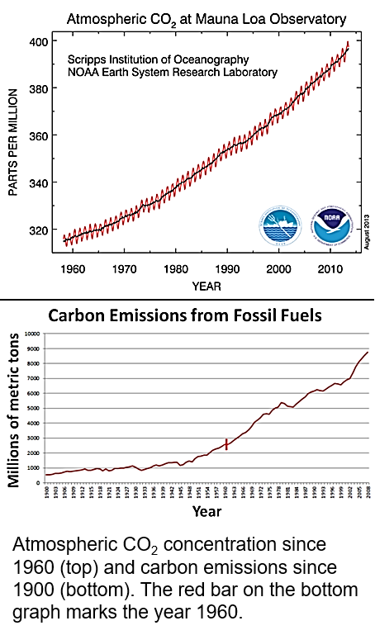

The below figure represents the amount of carbon emission from the year 1900 to 2008.

**Figure 4 Carbon Emission from Fossil Fuels** [4]

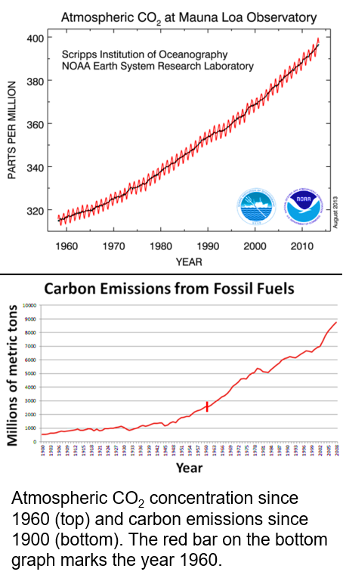

# **Why do we need to react now?**

We should drastically reduce the amount of CO2 emissions to save the future generation as well as our own life. Even if we make a wise decision now to efficiently use fossil fuels it would take our whole life to bring a small change towards climate change. This is because climate changes are permanent and it takes a lot of effort from all people to step forward and contribute to saving our world.

# **The History behind Carbon Capture and Sequestration Technology**

Enhanced Oil recovery is the method of obtaining pure oil from the ground. This method was developed in order to stop the harmful CO2 emitted from the industries and thereby stopping it from mixing the atmosphere. This method started in the United States in 1977 for increasing oil recovery [5]. Gas processing plants and thermal power plants were the major places where this method was carried out.

Global CCS is the firm responsible for carrying out research and development of this system. At the end of the year, 2012 totally of 30 CCS (Carbon Capture Sequestration) plants were built at different sectors to reduce CO2 emissions [5].

# **Alternate Carbon Capturing Technologies**

# **Pre-Combustion**

Pre combustion is the process of obtaining dioxides of carbon and hydrogen. This obtained dioxide is called syngas. At the further stage, this gas is passed through a chamber to react with CO2 and more amount of hydrogen [6]. CO2 is passed into the storage unit and hydrogen is used to generate electricity [6]. Membranes such as monoethanolamide (MEA), diethanolamine (DEA) can be used to trap the emitted CO2 and can be differentiated. In this way, CO2 can be trapped, stored and used for other purposes. The membranes can be recycled by heating and pressurizing and then can be reused for the process again [6].

# **Post Combustion**

The post-combustion method removes CO2 gas from the combustion process. Nitrogen is being used by the existing power plants for the combustion of flue gases and produces these gases which are at lower pressure and 15% less concentrated from CO2 [6]. It is difficult to create cost-effectiveness for this method as the partial pressure is approximately less than 0.15 atm. Amines react with carbon dioxide to form soluble compounds in water. Such formation results in the capture of carbon dioxide gas from flue gases [7].

# **Requirements and Criteria**

# **Requirements**

The addition of Carbon content to the clear area should be prohibited and we should take each and every necessary initiative to prevent it from expanding and sustain the overall integrity of our surrounding environment. This should lead to maintain the pollution levels in the normal stage and to a peaceful atmosphere in a breathable stage. Some of the proposed initiatives are listed below.

* The obsolete and electricity production methods such as consuming Fossil fuels and coals as raw sources should be prohibited and power generation through hydro and solar power should be adapted inaccurate manner.
* The critical steps should be taken by the administrative authority to support the sequestration methods and carry out a serious examination on a regular basis as if the roles are fulfilled by the companies.
* Research in Nanotechnology for carbon capture has proven to be effective as it has almost 99 % of the efficiency to filter out carbon from the air thus making it an effective substance [7].
* The power plant installation and maintenance and clearance fulfillment should be accurately carried out so there should be no need to make a compromise with the efficiency.

# **Criteria**

Considering all the important points, the successful implementation should be based on the listed criteria and fulfillment of this project.

* After the numerous researches and predictions, we have proposed the specific time frame and budgeting of the project and should be completed in a perfectly orderly manner.
* The issues encountered and faced because of the rules and regulations by the government and several industrial players should be confronted and overcome on an early note.
* The process of carbon capture in the different power plants should be eased by implementing a variety of practical operations.
* The awareness programs should be made available for carbon removal and different harmful gases from the carbon-producing power plants.

# **Solution Proposed**

We have defined the process and divided it into the section for a clearer understanding. The first section covers the explanation of the carbon composite from the power part. The second section states the chemical formulas in an understandable format which in the end explains the conversion process of carbon to nanotube conversion.

# **Capturing of carbon by Electrolyzer in power plant.**

Based on the previous methods such as the Conventional Mixed Cycle power plant, the CO2 gas is directly emitted to the atmosphere. But in this nanotube installed power plant, this gas is eliminated through the electrolyzer. Thus, in the result as an output form, the carbon nanotube is manufacture from the Carbon. Ultimately forming the carbon dioxide-free gas to be allowed to pass in the atmosphere.

**Figure 5:Conventional combined cycle power plant and CC Carbon nanotube power plant with electrolyzer** [8]

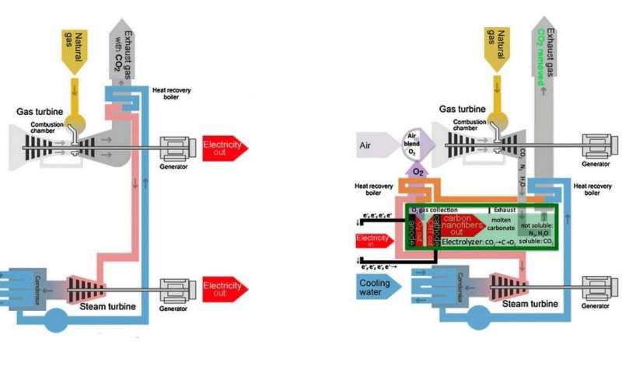

This combined cycle power plant and the carbon nanotube implemented in the area have molten carbonate electrolytes and that will be used to dissolve the CO2 gas and let it split by the method of electrolysis. Gases like Nitrogen, Oxygen and Water vapor of water stem are insoluble in the molten form of carbonate electrolyte. The nanotube fibers are extracted at the cathode and pure oxygen gas at the anode side. This way the efficiency can be increased. The main advantageous side of the proposed solution is that the vale of carbon nanotubes production will greatly exceed the value of electrical energy produced. So, we are capturing the carbon content and making revenue at the same time [8].

# **Process for Nanotube conversion**

The CO2 captured here is converted to the valuable products which make it profitable. The process of CO2 gas to Nanotube conversion; the Carbon particulate and O2 are separated using the electrolytic process in presence of Li2CO3 (Electrolyte) [9]. The reactions are shown below:

Dissolution: CO2(g) + Li2O(soluble) Li2CO3(molten) [9]

Electrolysis: Li2CO3(molten) C (CNT) + Li2O(soluble) + O2(g) [9]

Net: CO2(g) C (CNT) + O2(g) [9]

The process of separation of CO2 consists of two methods. They are as follows

**Dissolution:**

The solute is passed into the solution to dissolve. Carbon dioxide will dissolve with the lithium oxide and initiates it to create lithium carbonate in the molten form.

Dissolution: CO2(g) + Li2O(soluble)  Li2CO3(molten) [9]

**Electrolysis:**

With the help of this process, the Carbon element is separated from the source. The lithium carbonate generated from dissolution is breached down into the carbon (nanotubes) and lithium oxide (which is soluble) and releases pure oxygen.

Electrolysis: Li2CO3(molten) C (CNT) + Li2O(soluble) + O2(g) [9]

The final reaction of the entire process of dissolution and electrolysis forms the carbon Nanotube and oxygen gas.

Net: CO2(g)  C (CNT) + O2(g) [9]

# **Layout of the Plant**

The thermal power plant system is taken into consideration which is emitting CO2. This requires the carbon capture system to be installed at the exhaust exit. The ashes produced from burning the non-renewable fuel like coal is collected in the ashtrays [9]. The gases are allowed through the Electrolyzer which will convert the CO2, into Carbon Nanotube [9]. This process continuously takes place until the power plant is working. The backup system and exhaust can be installed for the regular maintenance alternatively. After the gases pass from the electrolyzer, the air quality can be tested and then it is allowed into the atmosphere with zero-emission from the electricity production [9].

The complete figure of the power plant is demonstrated in the figure below which is presented below, this has been equipped with the carbon-capturing facility.

**Figure 6: Layout of Power plant equipped with carbon capture facility** [8]

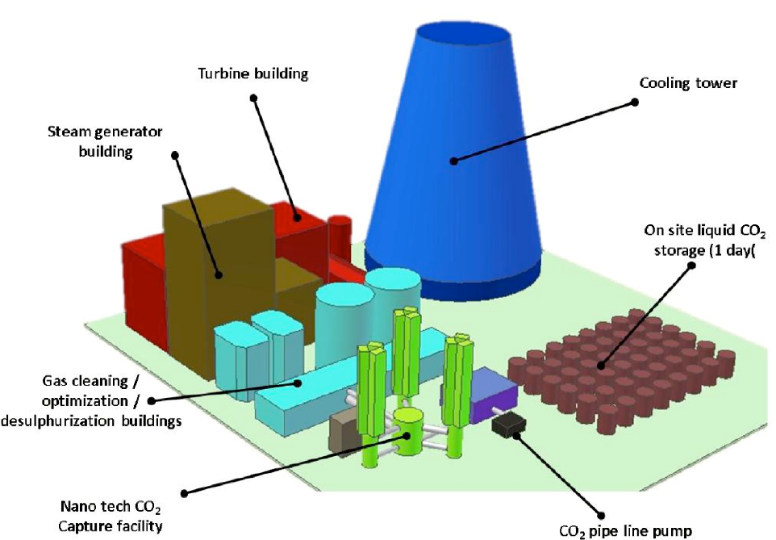

# **Comparison**

Table 1 shows how valuable the method will prove if we install the electrolyzer at the exhaust of the Coal based Power Plant [9]. Also, the emission will be reduced to almost 0% after the production of the electrical energy (Per ton of natural gas).

**Table 1: Comparison of two types of power plants** [8]

|  |  |  |  |
| --- | --- | --- | --- |
| Type | Carbon Emission | Cost of Electricity | Income from CNT |
| Without C2CNT | 2.7-ton CO2 | 909 $ | 0 $ |
| With C2CNT | 00-ton CO2 | 835 $ | 225,000 $ |

# **Advantages:**

Below are some of the advantages of the desired solution:

* This will make the power plant Almost 99 % efficient and reduction in emission of Carbon to the atmosphere [7].
* The environmentally friendly atmosphere will be harnessed in the city and this process can be proved to be generating extra revenue.
* This will drastically improve the air quality of the city.
* Low-cost trapping method of the CO2 as compared to other methods
* This process can even separate the different elements of gases at low temperatures.

# **Disadvantages**

The following are the disadvantages of the proposed solution:

* Regular maintenance and cleanliness measures should be followed on a timely basis in order to run this power plant as it emits a high volume of carbon.
* The Electrolyte should be replaced regularly.
* The efficiency of the power plant decreases by 8% [8].

# **Cost Analysis**

# **Initial cost of the project**

The initial cost is as follows:

1. Electrolyzer chamber CAD 5000.
2. Li2O CAD 100/ lb.
3. Electrode CAD 5000/ ton.
4. Engineering and Offices [10] CAD 38000
5. Civil structure [10] CAD 27000
6. Electricals [10] CAD 28000
7. Piping [10] CAD 33000

The total initial cost of the project is approximately 136,100 CAD.

# **Operating cost of the project**

**Table 2:Comparision of the per ton production of CNT and aluminum** [8]

|  |  |  |  |
| --- | --- | --- | --- |
| C2CNT Process  (Parameters) | Cost  (CAD $) | Aluminum Process  (Parameters) | Cost  (CAD $) |
| Carbon | 0 | Carbon | 317.5 |
| Capital | 200 | Capital | 200 |
| Labor | 190 | Labor | 190 |
| Electricity | 472 | Electricity | 790 |
| Alumina | 0 | Alumina | 954 |
| Total | **862** | **Total** | **2451.5** |

# **Proposed Timeline**

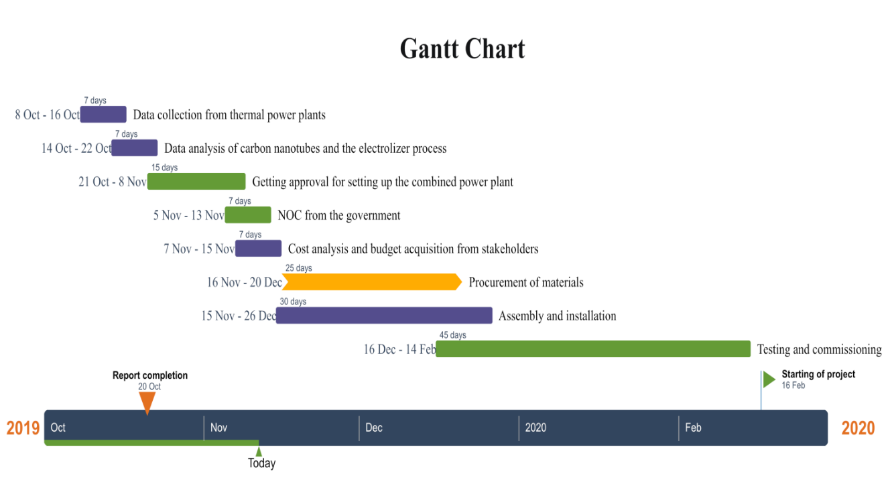

# **Final Recommendations and Conclusion for Project**

Covering all of the researches and fulfilling the criteria of logic and the developmental part we have come close for the solution to capture carbon dioxide which is released from Industries and is spreading it into City Area. The carbon nanotube is a resolution to the exhaustion of chimneys in the power generation plants. As the tubes are highly effective and available at a low price so, the installation cost will be affordable [8]. Our aim is to minimalize the overall quantity of Carbon in the city landscape and maximize our efforts to reduce its composition in the atmosphere.

The pertaining desires why we selected the sequestration techniques of carbon by electrolyzers:

* This method can separate the gas at below temperatures.
* The trapping of CO2 is easier and economical than other methods.
* Finally, because of the less spending, the process seems to be profitable and can generate extra revenue.

As natural gas is the major source of (GHG) emission in Windsor, the team has decided to tackle the containment of carbon dioxide gas from power plant exhaust as power plants utilize natural gas the most for electricity generation [1]. Detailed analysis of the impacts on this top can be carried out to discover and rectify critical sections for solutions to contain carbon content. To reduce the productions of greenhouse gas, several processes can be optimized to reduce pollution. Apart from this, a major share of carbon dioxide is transportation, which should be investigated to cut off more carbon dioxide [1]. According to a recent study, the 2-degree increment in global temperature will affect millions of citizens to experience disastrous weather phenomena and led to an extinct.

# **Required finance for Overall Project development.**

The initial costing for this project will be 136,100 CAD approximately and additional costs such as operation carrying are expected to be near and operational cost is expected to be around 862 CAD and 2451.5 CAD per ton of carbon nanotube production in C2CNT and Aluminum process respectively. We have expected to define a timescale of 300 working days for complete implementation.

It is a sincere request that the governmental body should carry out the alternative solutions of carbon dioxide isolation which is released from the exhaust of automobile bodies and several different sources and to take necessary steps to minimize CO2 emission to the atmosphere as well as geosphere.

# **References**

|  |  |
| --- | --- |
| [1] | "Electropaedia," [Online]. Available: https://www.mpoweruk.com/fossil_fuels.htm. [Accessed 05 November 2019]. |
| [2] | "The city of Windsor, Ontario, Canada," [Online]. Available: https://www.citywindsor.ca/residents/environment/climate-change-mitigation/community-energy-plan/Pages/Windsor-Greenhouse-Gas-Emissions.aspx. [Accessed 02 November 2019]. |
| [3] | "The City of Windsor, Ontario, Canada," [Online]. Available: https://www.citywindsor.ca/residents/environment/Environmental-Master-Plan/Goal-A-Improve-Our-Air-Quality/Pages/Community-Greenhouse-Gas-Emissions.aspx. [Accessed 03 November 2019]. |
| [4] | "Climate Institute," [Online]. Available: http://climate.org/humansandthegreenhouseffect/. [Accessed 04 November 2019]. |
| [5] | "ieaghg," [Online]. Available: https://ieaghg.org/docs/General_Docs/Publications/Information_Sheets_for_CCS_2.pdf. [Accessed 04 November 2019]. |
| [6] | L. D, S. Roussanaly, S. Westman and J. Husebye, An Overview of current status of carbon dioxide capture and storage technologies, Energy Procedia, Vol. 37, pp.7039-7045., 2013. |
| [7] | D. Drikakis. [Online]. Available: http://drikakis.com/research/CarbonCapture.pdf. [Accessed 05 November 2019]. |
| [8] | J. R. M. L. G. L. J. V. S. L. M. Johnson, "Data on SEM, TEM and Raman Spectra of doped, and wool carbon nanotubes made directly from CO2 by molten electrolysis," *Science Direct,* pp. Volume 14 592-606, October 2017. |
| [9] | J. R. M. L. G. L. J. V. X. L. S. L. M. Johnson, "Carbon nanotube wools made directly from CO2 by molten electrolysis: Value driven pathways to carbon dioxide greenhouse gas mitigation," *Science Direct,* pp. Volume 5, 230-236, September 2017. |
| [10] | D. Pauschert, "Study of Equipment Prices in the Power Sector," *Energy Sector Management Assistance Program,* vol. 122/09, 2009. |